6.18 B

QUESTION 1
Give an example of a compound machine. Explain how at least two simple machines are part of the complex machine.

QUESTION 2
When you lift a book from the ground to your desk, what kind of work do you do, negative or positive? By lifting the book, what do you change? Does the book gain or lose energy? What kind of energy?

QUESTION 3
Describe the motion of a pendulum in terms of kinetic and potential energy. As the pendulum moves from its greatest to lowest height and back up again, how does its energy change? When is each type of energy the greatest and the least? What is true about the total mechanical energy of the pendulum?

QUESTION 4
On a waterslide, describe the kinetic and potential energy you have at the top of the hill and at the bottom of the slide. What affect does friction have on you throughout the ride?

QUESTION 5
What are the parts of a pendulum? Describe each one.

QUESTION 6
Define mechanical energy. Using the example of the skateboarder on the half-pipe, explain how kinetic and potential energy relate to the mechanical energy at different positions.

QUESTION 7
A 25-kg child sits at the top of a 4-meter slide. After sliding down, the child is traveling at 5 m/s. How much PE does he start with? How much KE does he end with? How much energy is lost to friction?

QUESTION 8
You push a box across the floor with a force of 30 N. You push it 15 meters in 8 seconds. How much work did you do? How much power did you use?

7.18 B

QUESTION 1
On a cold winter's day, if you left a cup of water sitting outside, it could freeze. Heat is transferred out of the water. Describe the behavior of the water molecules and how temperature is affected.

QUESTION 2
When heat is removed from a substance, describe how the molecules are affected. Use the words kinetic energy and potential energy appropriately.

QUESTION 3
A piston in a heat engine does 500 joules of work, and 1,400 joules of heat are added to the system. Determine the change in internal energy and explain how this example demonstrates the conservation of energy.

QUESTION 4
What components of a gas-powered car are present in a hybrid? What components of an electric car are present in a hybrid?

QUESTION 5
Describe which renewable resources are used primarily to produce electricity and which renewable resources are readily used as heat sources for homes.

QUESTION 6
What does a plant use in photosynthesis and what are the products?

QUESTION 7
What determines the temperature of an object at the molecular level?

QUESTION 8
List two fossil fuels. Describe how each was formed and how they are different from each other.

8.18 B

QUESTION 1
What is the wavelength of a wave if the wave speed is 24 m/s and the frequency is 48 Hz?

QUESTION 2
The frequency of a G note is 392 Hz. If the speed of sound is 343 m/s, what is the wavelength?

QUESTION 3
Why do xylophone bars have different lengths?

QUESTION 4
Compare longitudinal and transverse waves.

QUESTION 5
Describe how the Doppler effect explains why an apraoching fire engine's siren has a high pitch.

QUESTION 6
Why do cowboys in movies put their ears to the ground to listen for enemies?

QUESTION 7
Explain why a mechanical wave does not exist in a vacuum.

QUESTION 8
How does the frequency of a wave relate to the energy of the wave?

9.18 B

QUESTION 1
Explain what happens when two light waves traveling from opposite directions of displacement meet?

QUESTION 2
Compare and contrast microwaves with visible light using wavelength, frequency, and energy.

QUESTION 3
Explain the process by which microwaves work to heat food, and then describe how they carry cell phone conversations.

QUESTION 4
The law of reflection states that the angle of incidence equals the angle of reflection. Define the angle of incidence in terms of a line normal to the surface.

QUESTION 5
State the types of images do convex and concave mirrors create. Describe how each type of image is created.

QUESTION 6

Identify three devices that use convex lenses.

QUESTION 7
Explain the role rods and cones play in vision.

QUESTION 8
The diagram shows a ray of light striking a mirror that is above a sink full of water. Complete the diagram by drawing the path of the light as it leaves the mirror and enters the water.
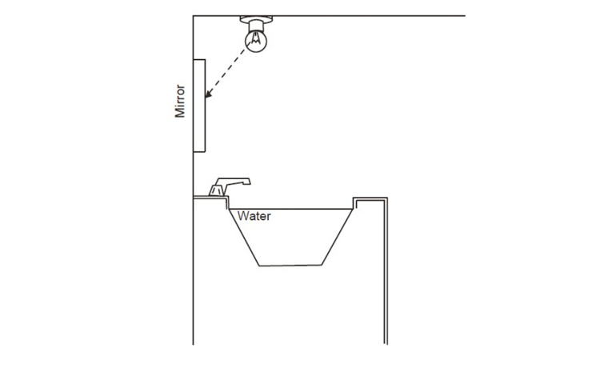

10.17 B
QUESTION 1
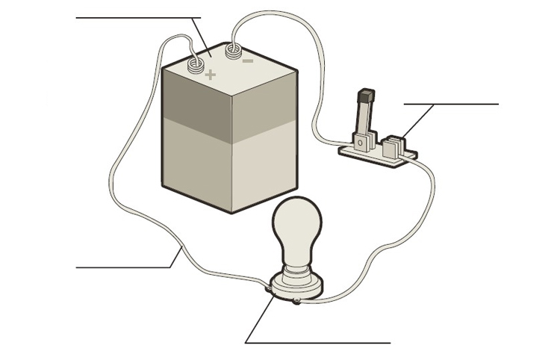
What is the purpose of each of the components of the circuit shown in the diagram?

QUESTION 2
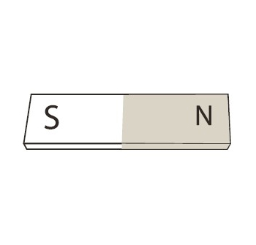
Describe the magnetic field in the vicinity of this magnet.

QUESTION 3
- How can you build an electromagnet?

QUESTION 4
- Explain the difference in how current flows through two light bulbs connected in series curcuit and in two light bulbs connected in parallel circuit.

QUESTION 5
- What are two household appliances that use an electric motor. What does the motor make happen in each appliance?

QUESTION 6
- How is the Earth’s magnetic field like a bar magnet’s magnetic field?

QUESTION 7
- Will these balloons be repelled or attracted? Why?

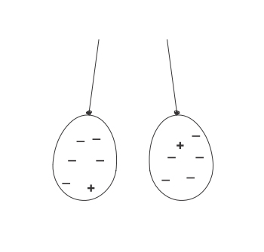

QUESTION 8
- What is one way you can make a difference and conserve energy in your home?

